Vaping
Liquid Smoke and Mirrors?
Rick Rayl
Director of Pharmacy UBH Denton
rirayl@aol.com

E-cig A Modern Day Debate
“Young people have taken a technology that was supposed to help grownups stop smoking and invented a new kind of bad habit, one that they have molded in their own image. The potential public-health benefit of the e-cigarette is being eclipsed by the unsettling prospect of a generation of children who may really love to vape.”

Jia Tolentino, “The Promise of Vaping and the Rise of Juul,” The New Yorker (May 14, 2018)

JUUL (pronounced “jewel”)
- Company opened in 2015 and has captured >70% if the e-cig market
- FDA is investigating allegations of marketing directed at youth
- Altria (big tobacco) has 35% stake in JUUL
  - 12.8 Billion dollars
Popularity among young people
- Resembling a flash drive, Juuls are sleek, easily concealed…
  - Peer pressure in schools encourages non-users to try
  - Social media glamorizes the use
- Sweet flavors like mint, mango, and crème brulee lure in youth
  - Large number did not realize getting nicotine
- … and difficult to detect
  - Put out less vapor than e-cigs
  - JUUL puts off a sweet, fruity smell—easily mistaken as perfume or hair product
The Smart E-cig
- Blue tooth
  - Track usage
  - Play music
  - Make a receive phone calls
- Hit control
  - Manually change nicotine amount without changing tanks
- Flavor mix
  - Adjusts flavors between tanks
- Auto mode
  - Adjusts nicotine to your usage
How do teens get vapes?
- Vape shops
- Websites such as vaporbeast.com and Etsy

FDA Crackdown
- Company’s response to FDA
  - Pulled various flavored pods from retail stores
    - Mint and menthol only flavors allowed
    - Plan to reinstate flavors with proof of age verification
    - Secret shopper program to check for compliance
  - Removed itself from social media
  - To prevent sales to underage users
    - ID match and age verification technology for online sales
    - Company has monitoring systems and penalties in place for resellers
E-Cig Regulation
- Regulated as tobacco product in 2016
- Attempt to regulate device as drug-delivery system struck down in federal court
- Each tobacco product must go through application process
  - Deadline for application pushed back to 2022
- April 2018 FDA issues mandate to crackdown to sales to minors
  - Juul advertising tactics appealing to youth
  - Address flavor issue as it applies to tobacco use and addiction in teens
E-Cig Regulation- Texas
- Prohibited sale of product/devices to purchaser under age 18
  - Retailers must verify age
- Possession of product/devices to person under age 18 prohibited
  - Unless in presence of “adult parent”, guardian or spouse
- Vending machines must be inaccessible to persons under 18
- Areas of use restricted by state and local laws
Vaping devices
- E-cigarettes
  - Advantages
    - Looks like cigarette
    - Portable
  - Disadvantages
    - Bad battery life
    - Often not refillable
- Vape Pen
  - Advantages
    - Portable
    - Good battery life
    - Refillable
  - Disadvantage
    - Bigger than e-cig
- Vape Mod
  - Advantages
    - Good battery life
    - Variable voltage
    - Customized settings
    - More powerful
  - Disadvantages
    - Bulky
    - expensive
Variable voltage vs variable watts
- Watts is how much power e-cig produces
- Voltage is how much is put through the device
- Increase watts, increase voltage
- Wattage = ratio between ohm setting for the coils and the voltage being applied
“Dry Throat Hit”
- Hot, burnt taste as a result of inadequate e-juice absorption while the device is heating
  - Wick not moist, so scorches producing burnt taste
- Causes:
  - Improper wicking
  - Overused cotton
  - Using a faulty unit
  - High wattage
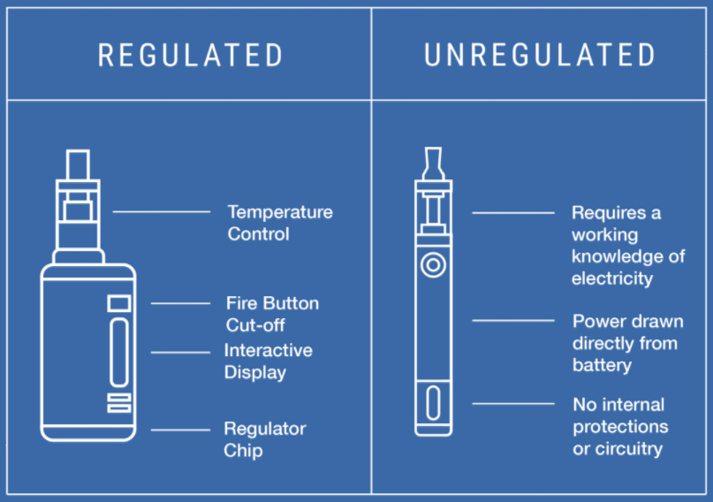
Contains current regulating circuitry which
keeps voltage and resistance w/in normal levels
Not for the inexperienced user; hard
on the parts of the device
Most mods are regulated
Dripping, Appling liquid to the exposed heating coils
- 1 in 4 teens who vape use this method
- Produces thicker clouds of vapor
- Enhances the taste of flavors
- Most harmful way to vape due to high heat
  - Metal from coils inhaled
- Chemicals released are associated with:
  - Cancer
  - COPD
- Handling liquid exposes teens to direct skin contact with nicotine
  - Absorbed rapidly through human skin
Big Tobacco & Research
- Safety of e-cig vs cigarette funded Tobacco industry
  - Recent study used genetically engineered lung tissue to compare
  - Dramatic drop in lung inflammation with e-cig
- Signals a shift in playbook for tobacco companies
  - Aware that young people’s use of cigarettes is trending down
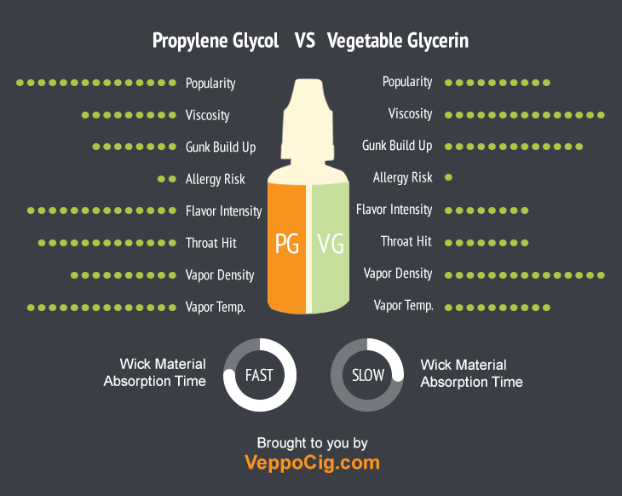

“The Flavoring Deception”
- Flavors are a primary draw of electronic cigarettes
  - CDC/FDA survey
    - 31% cited availability of flavors as reason for use
- Kids often think they are only vaping flavor
  - Truth initiative study

“Still blowing smoke”
- Evidence is mounting for link between
e-cigarettes and eventual smoking
  - Teens vaping e-cigs 7x more likely to smoke
cigarettes later on
    - NIH-funded study published in Pediatrics, Dec. 2017
  - Teens who smoke e-cigs are more likely
to try cigarettes
    - A consensus report by National Academies of Sciences, Engineering and Medicine, January 2018
  - E-cig use increases risk of beginning tobacco
cigarette use in young adults
    - A study by University of Pittsburgh Schools of the Health Sciences
published in the American Journal of Medicine, 2017
Nicotine
- Found in foods
  - Eggplant 100ng/g; green tomato 42.8ng/g
  - Cauliflower 16.8ng/g, potato 7.1ng/g
Nicotine age-related dementia
- Increases dopamine which improves cognition
- May reduce loss of neurons that produce dopamine and may be tied to growth factors in the brain that could reduce degeneration
- 15-21mg/day improves cognition
- Seems more of a treatment than a preventative
“Harmless” Vapor
- Toxic chemicals are formed as the e-liquid heats up to
make the aerosol that e-cig users inhale
  - Examples: Formaldehyde, benzene, arsenic, acetone
Popcorn lung?
- Diacetyl is added to food to produce a buttery taste and is perfectly harmless when ingested this way
- Inhaling it over a long period may prove harmful to health,
  - Linked to bronchiolitis obliterans (a lung disease)
- Findings confirm the presence of diacetyl and “other flavoring chemicals” in e-juices
- CDC urgently recommending more studies into dangers
E-Cig Regulation
- Regulated as tobacco product in 2016
- Attempt to regulate device as drug-delivery system struck down in federal court
- Each tobacco product must go through application process
  - Deadline for application pushed back to 2022
- August 10, 2018 FDA issues mandate for health warnings on packaging

